**Exercise**

**Problem Statement:** There can be multiple customers, who can place multiple orders on the site. Now a sales person can handle these orders will distribute into multiple sales persons (One order will be assign to one salesperson only). So a sales person can have multiple orders of multiple customers

1. Create Database

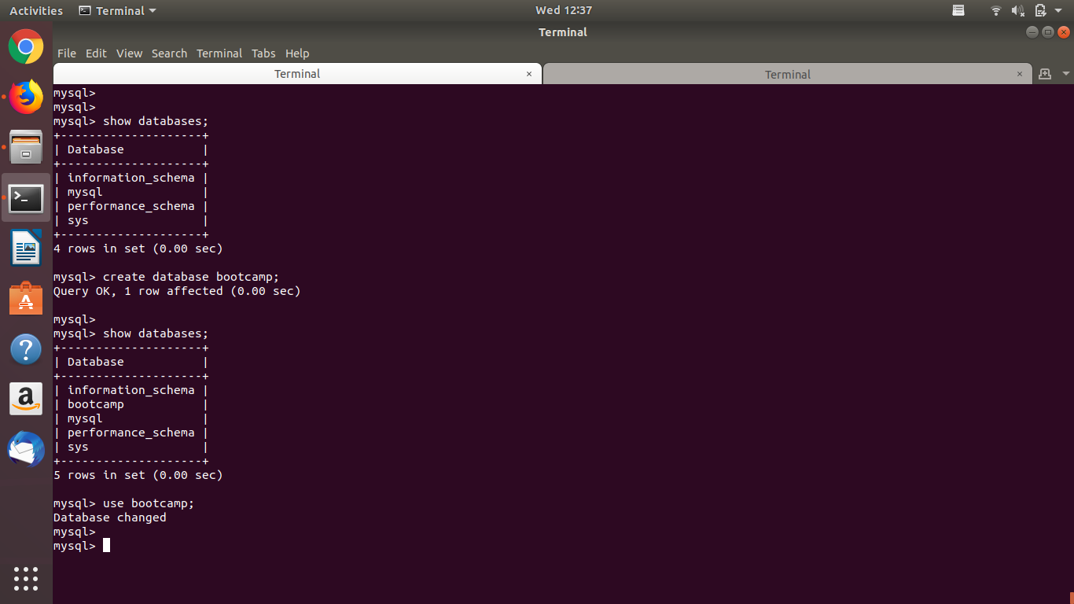

Created database bootcamp

1. Design Schema

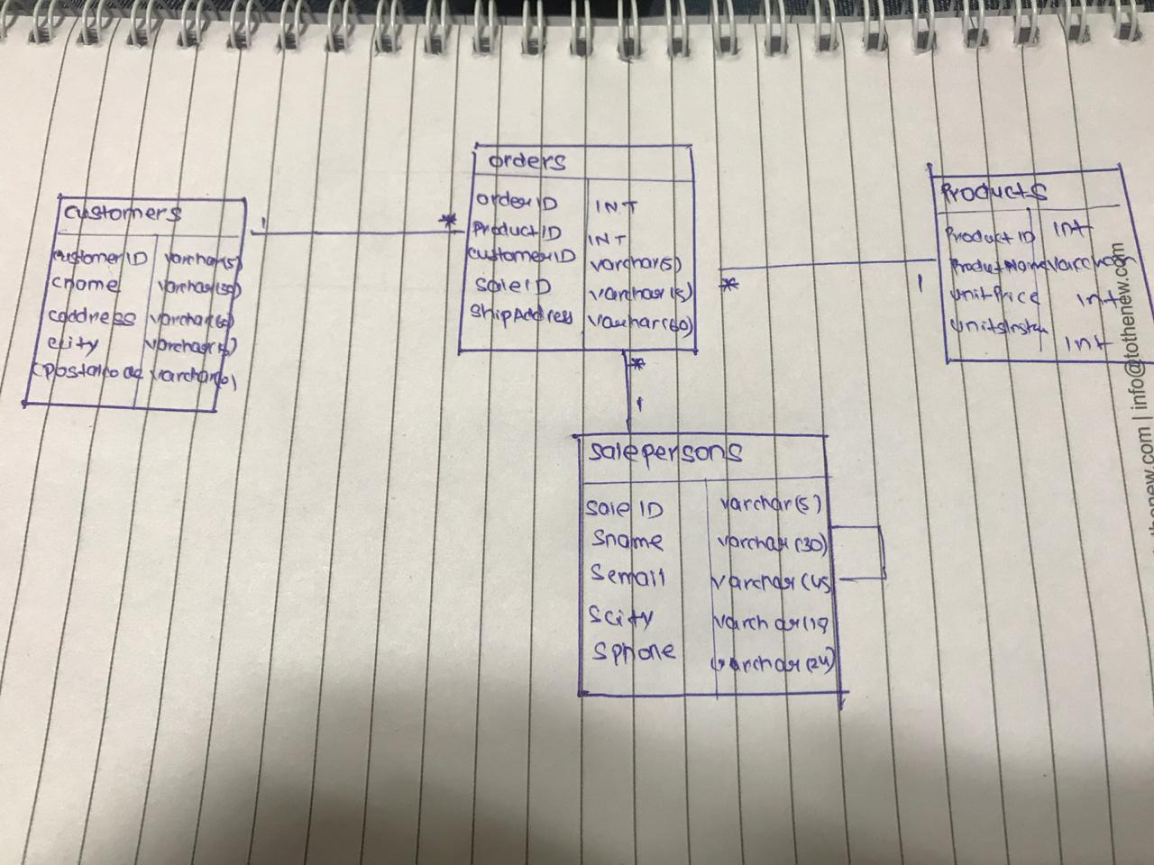

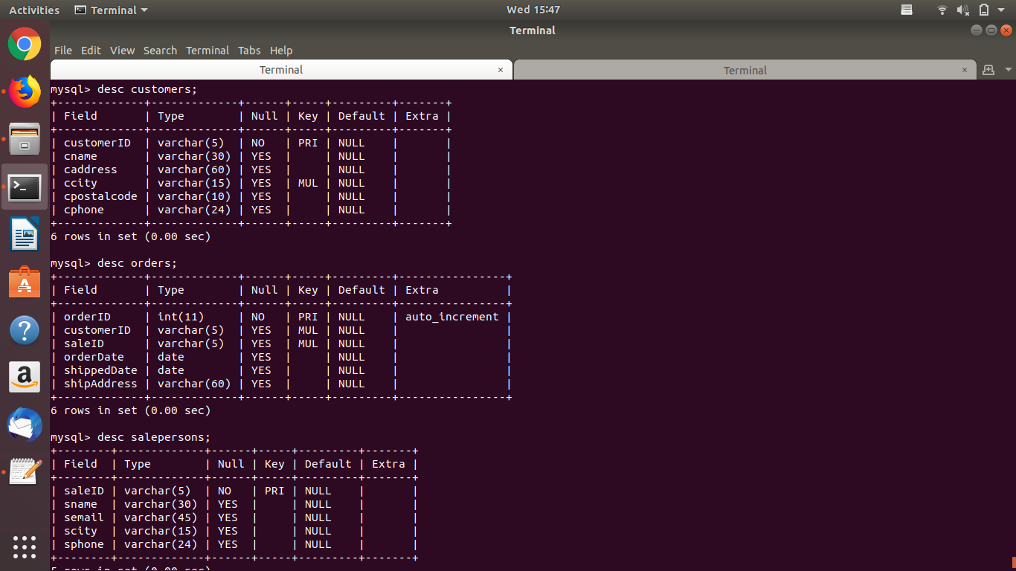

1. Create tables

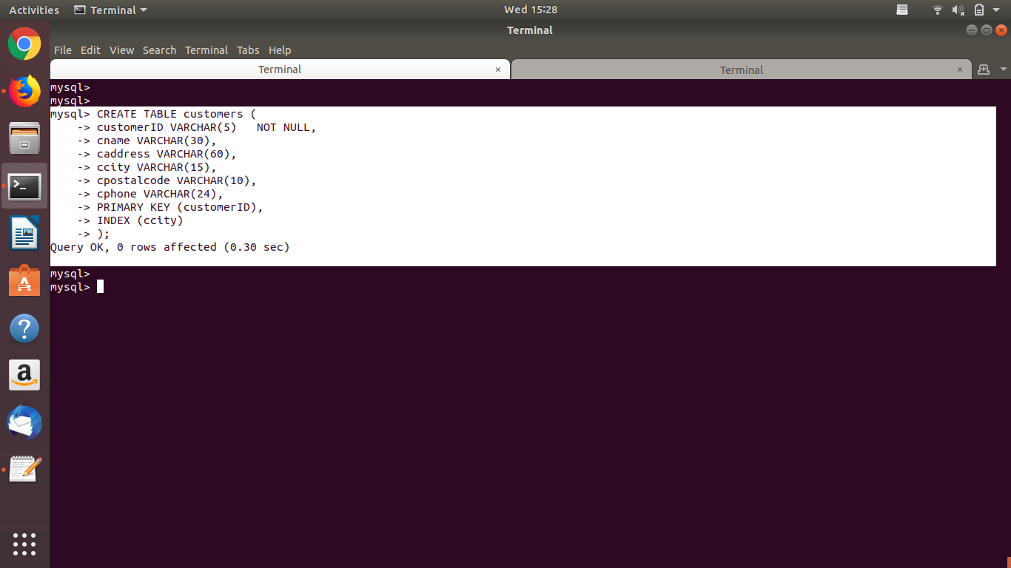

Created customers table

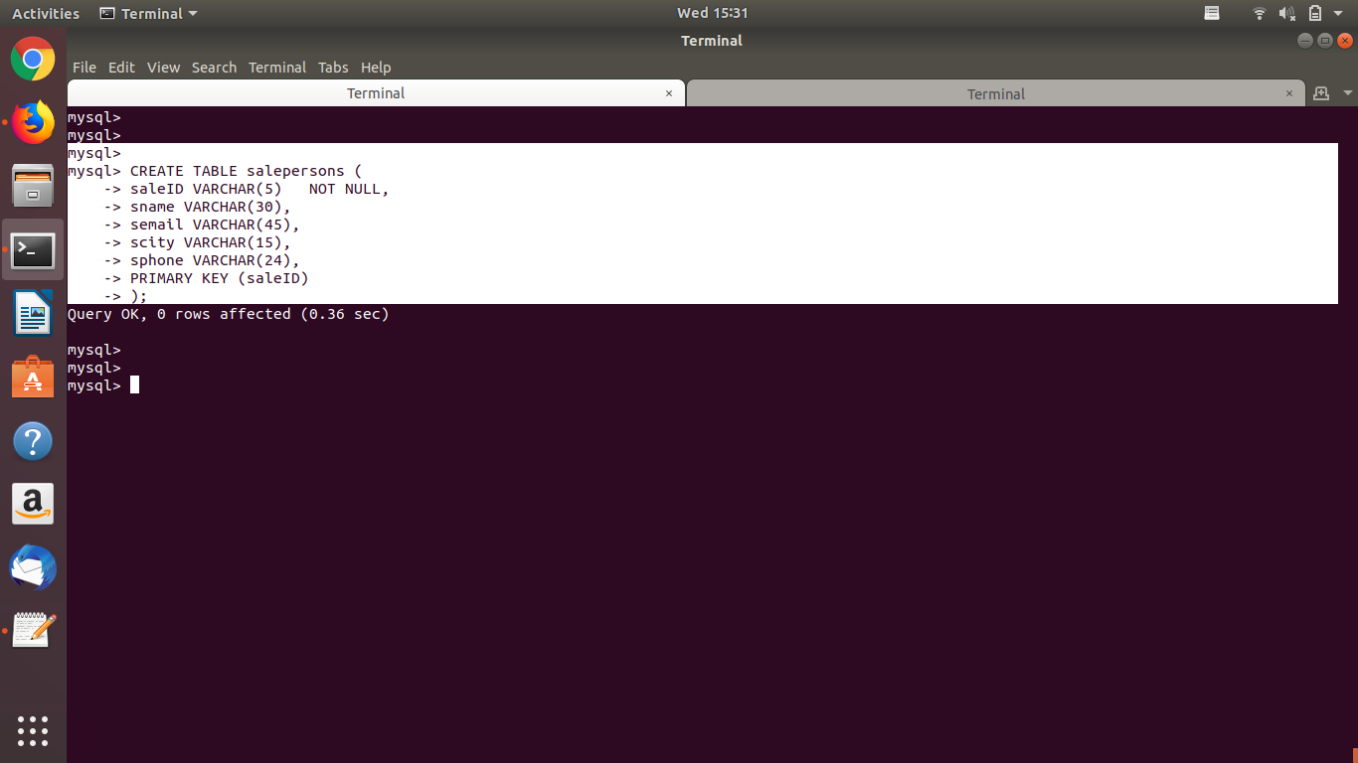

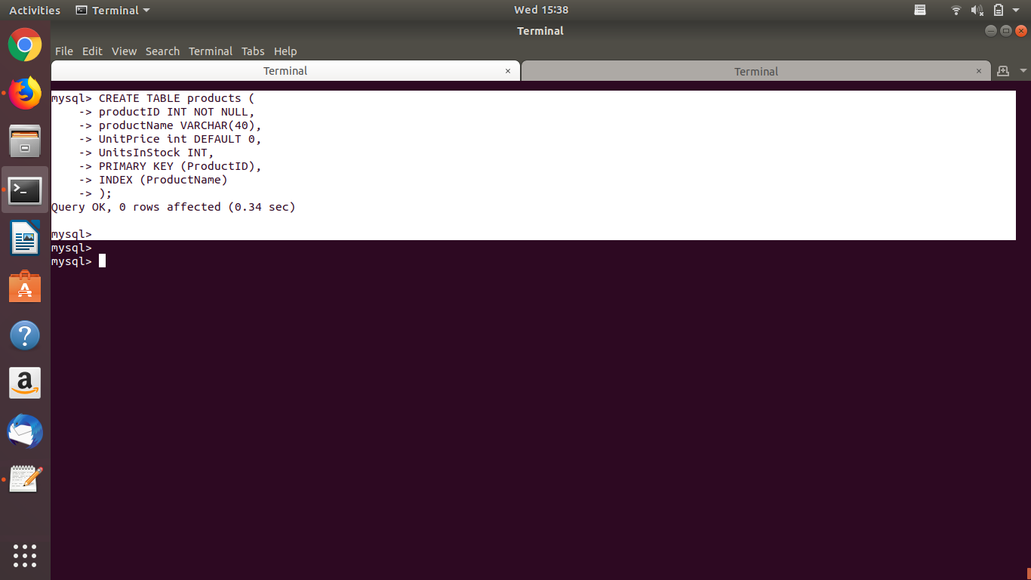

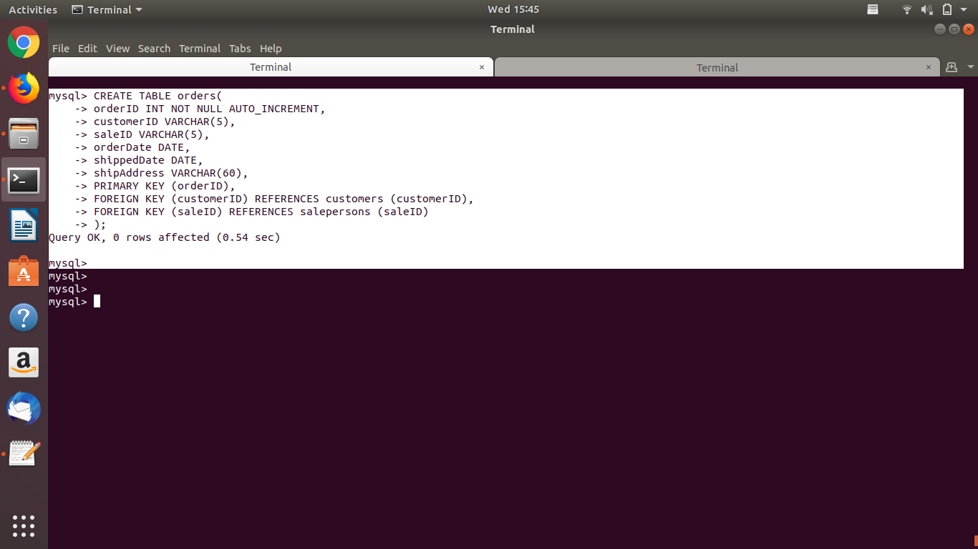

Created other tables

1. Insert sample data

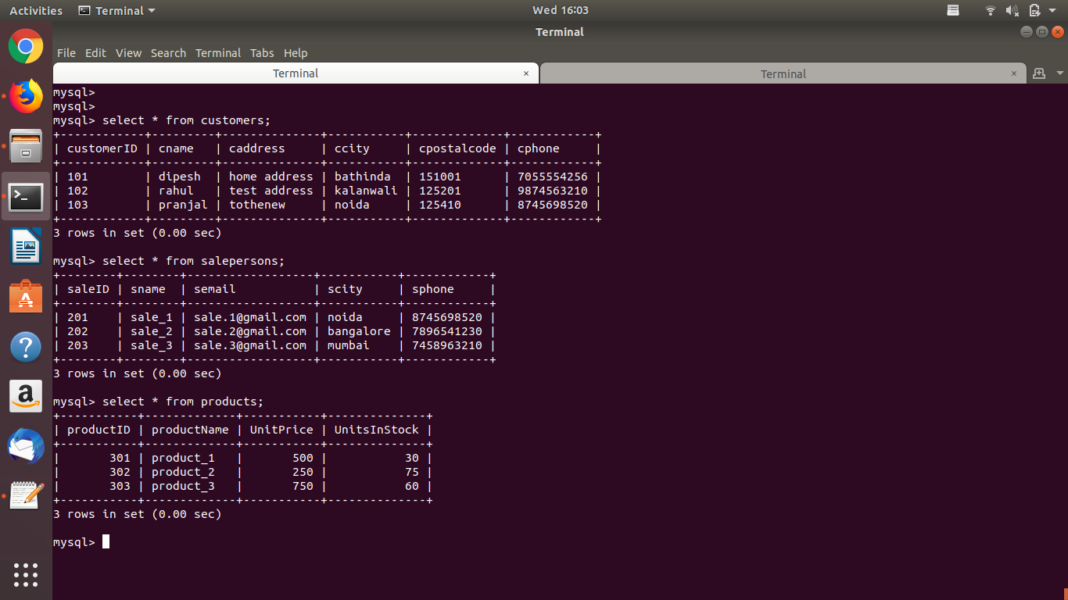

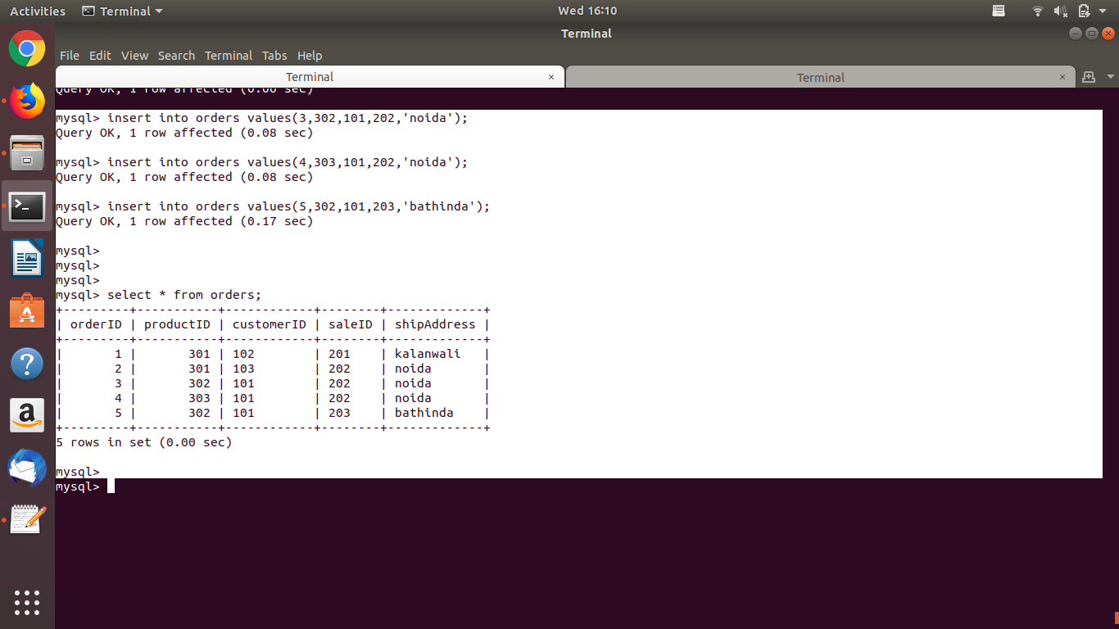

Data in orders table with FOREIGN KEY dependencies

1. Find the sales person have multiple orders.

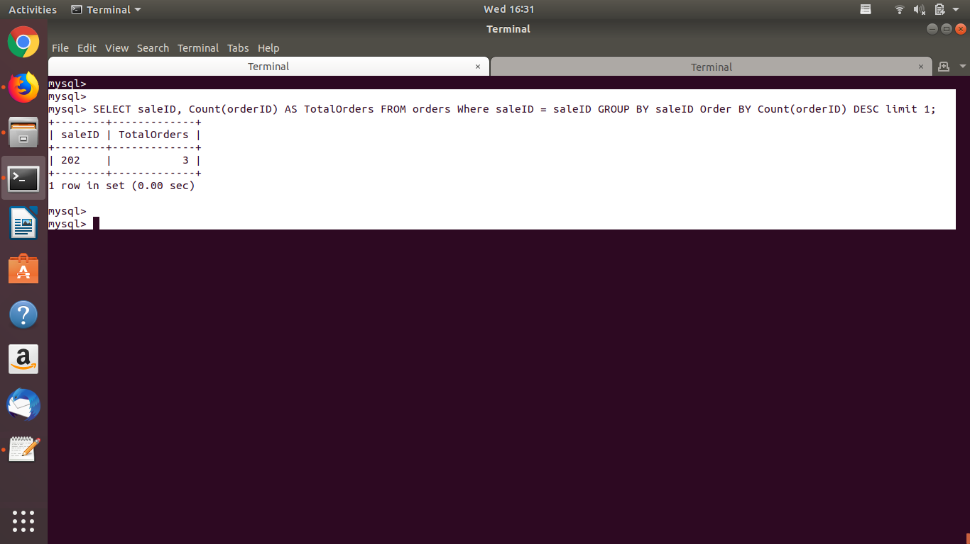

1. Find the all sales person details along with order details

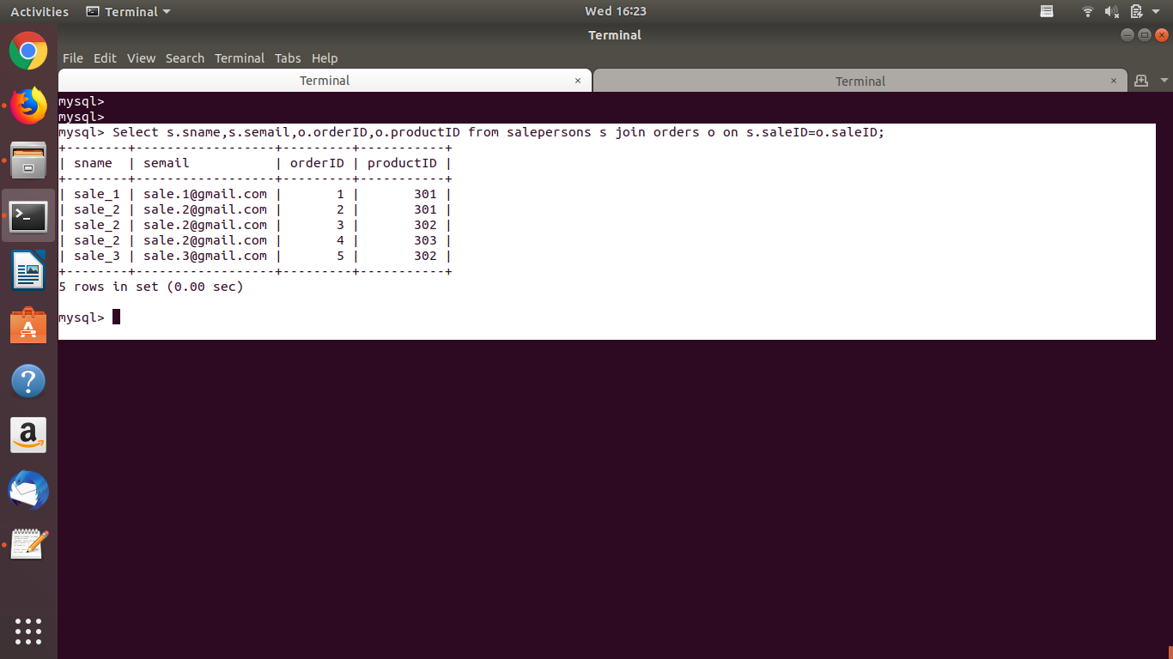

Use of Inner join

1. Create index



1. How to show index on a table

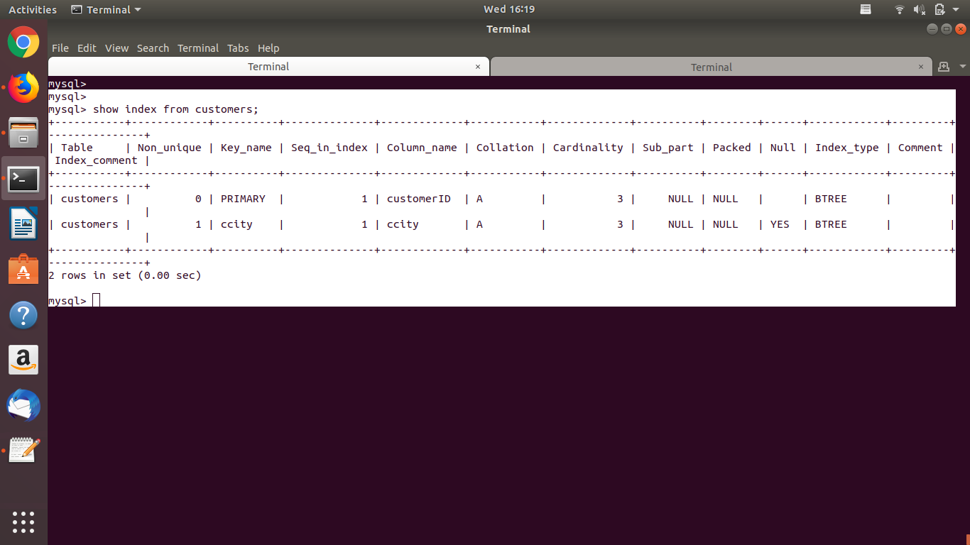

9. Find the order number, sale person name, along with the customer to whom that order belongs to.

